A

Project Report on

**WATER QUALITIES -DATA ANALYTICS**

Submitted in partial fulfillment of completion of the course

Advanced Diploma in IT, Networking and Cloud

Submitted by:

MANJIMA BHATTACHARYYA

Under Guidance of:

**Edunet Mentor- ARPITA MAM (Edunet)**

|  |  |  |
| --- | --- | --- |
| IBM-Logo - Chicago Innovation | DGT introduces high end diploma courses - digitalLEARNING Magazine | Edunet Foundation-Delhi- CSR Organization profile |

Year 2022-24

Abstract

Acknowledgement

Table of Contents

1. Introduction to Problem
2. Literature Review
3. Proposed Solution
4. Requirements

4.1 Technology Stack

4.2 Hardware

4.3 Software

4.4 Deployment Environment

5. User Requirements

6. Design Documentation

7. Implementation Details

8. Testing

9. Deployment

10. Future Scope

11. Conclusion

Appendix A Screenshot of Project

References

**ABSTRACT**

Water Quality index several datasets including Temperature (°C), Turbidity (NTU), Dissolved Oxygen (mg/L), Conductivity (µS/cm), ph, hardness, sulfate, solids etc.As per normal water parameters my dataset is different so for that reason we have to filtered it, then moved on to visualization, and eventually created a prediction model for this data set. I need to check the quality of water is good or not because Only 3 % of Earth's water is fresh water.

**ACKNOWLEDGEMENT**

Dazzle (Manjima Bhattacharyya). I would like to express my special thanks and gratitude to my teacher Ms Arpita Roy who gave me the golden opportunity to do this project.

So, it really helps me in doing a lot of research and I came to know about many new things. It really helps me a lot to increase my knowledge and skills.

**INTRODUCTION TO PROBLEM**

It helps people to understand the quality of water is good or bad and also its safe or not. It also helps people in agriculture, industry, and electricity etc. Only 3 % of Earth's water is fresh water. 1 % of this fresh water is fit for drinking. My research is to testing water quality like ph, Turbidity (NTU), Temperature (°C), Dissolved Oxygen (mg/L), etc. It helps to detect whether the water is suitable for human consumption, fish health, etc.

|  |
| --- |

**PROPOSED SOLUTION**

Plant more trees and plants. Do a beach clean-up if you live by the coast or remove plastic from rivers near your home. Finally, the issue of water pollution should always be in the back of your mind during daily activities. Rainwater harvesting systems to collect and store rainwater for drinking or recharging underground aquifers. Build wells to extract groundwater from underground aquifers. Provide home water-treatment capability through the use of filters, solar disinfection, or flocculants, to make drinking water safe.

**REQUIREMENT**

|  |  |
| --- | --- |
| Technology Stack: | PYTHON, NUMPY, PANDAS, MATHPLOTLIB, SEABORN |
| Hardware: | Processor: Intel(R) Core (TM) i5-9500 CPU @ 3.00GHz 3.00 GHz System type 64-bit operating system, x64-based processor |
| Software: | JUPYTER NOTEBOOK |
| Deployment Environment: |  |
|  |  |

**USER REQUIREMENT**

* 1. Industrialization
  2. Household Needs
  3. Agriculture
  4. For hydro-electricity generation
  5. For cooking purpose.
  6. For feeding plants

**DESIGN DOCUMENTATION**

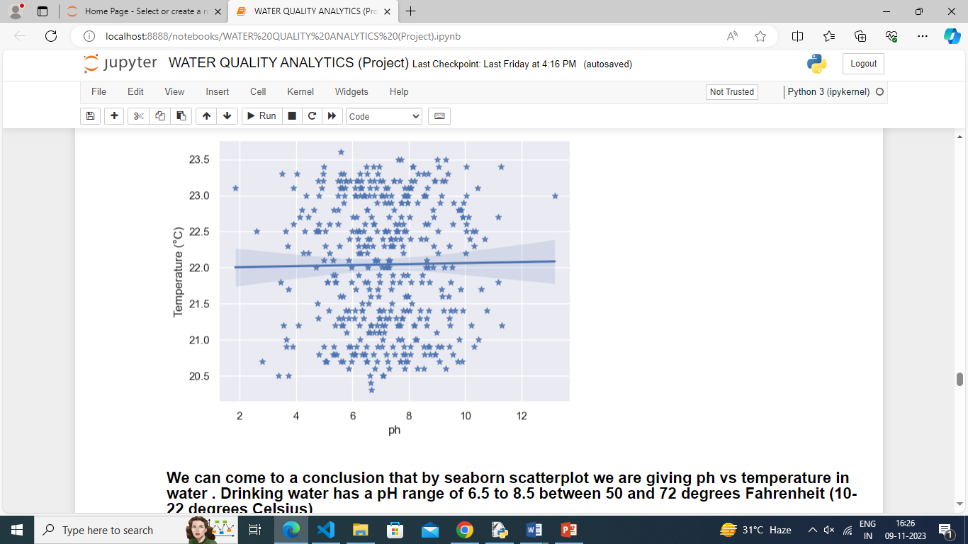 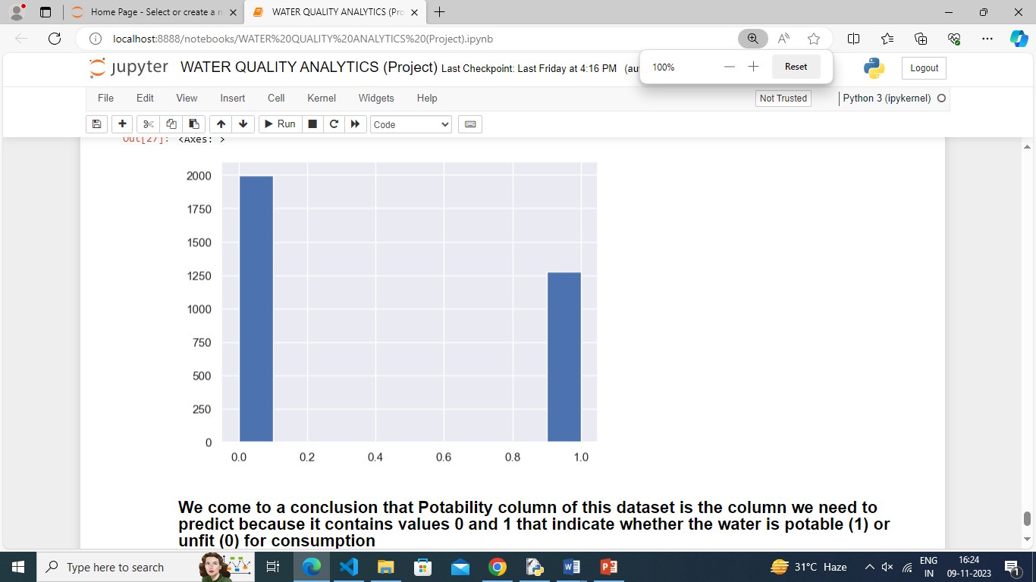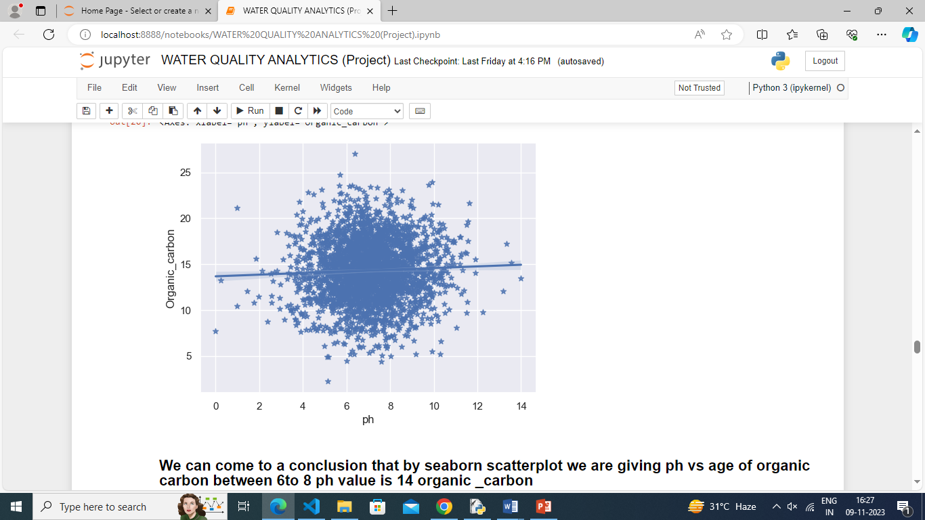

**IMPLEMENTATION DETAILS**

**STEP1**- Firstly, I have to download csv file from Kaggle(<https://www.kaggle.com/datasets/shreyanshverma27/water-quality-testing>).

**STEP 2-** Secondly, I have to exact file.

**STEP 3-** I have to open JUPYTER NOTEBOOK.

**STEP 4 -** I have to import all libraries like NumPy, pandas, math plot, seaborn etc.

**STEP 5 -** Then, I have to read the whole csv file by this command [df = pd. read_csv ('Water Quality Testing.csv')

print(df)]

**STEP 6 -** Then I have to give full information about csv file by using this command (df.info ()).

**STEP 7 –** Then I have to take the backup file from my original dataset and describe it also. [ water _backup = df1.copy()] [ missing_water_data = water_backup [water_backup. is null (). any(axis=1)]

missing_water_data] [water_backup. describe ()]

**STEP 8 -** I have to show different charts and graph for understanding that in my csv file the parameter of water is high or low than normal water parameter and is also save for drinking, or some necessary work.

**STEP 9 -** Correlation matrix heat map. So, we have to check the quality of water for everything. It shows the relation with all.

**STEP 10 –** I have to update and improve your platform based on user because day by day the quality of water is getting bad/poor.

**FUTURE SCOPE**

water quality monitoring is a complex and multifaceted arena. Like any area, there is always room for improvement and as technology continues to advance and develop, scientists are looking at new ways to gather data, share information and use results to make better decisions. the future of water quality monitoring is a focus on long-term, comprehensive strategies. Across the globe governments and environmental organisations are starting to roll out new policies.

**CONCLUSION**

The physical, chemical, and biological parameters of water quality are reviewed in terms of definition, sources, impacts, effects, and measuring methods. The classification of water according to its quality is also covered with a specific definition for each type. water unsuitable for one use may be quite satisfactory for another and water may be considered acceptable for a particular use if water of better quality is not available.” It shows the water is acidic or alkaline. Pure water has 7pH value, less than 7pH has acidic, more than 7pH has alkaline. The range of pH is 0-14 ph. For drinking purpose, it should be 6.5-8.5pH.

**Appendix Screenshot of Project**

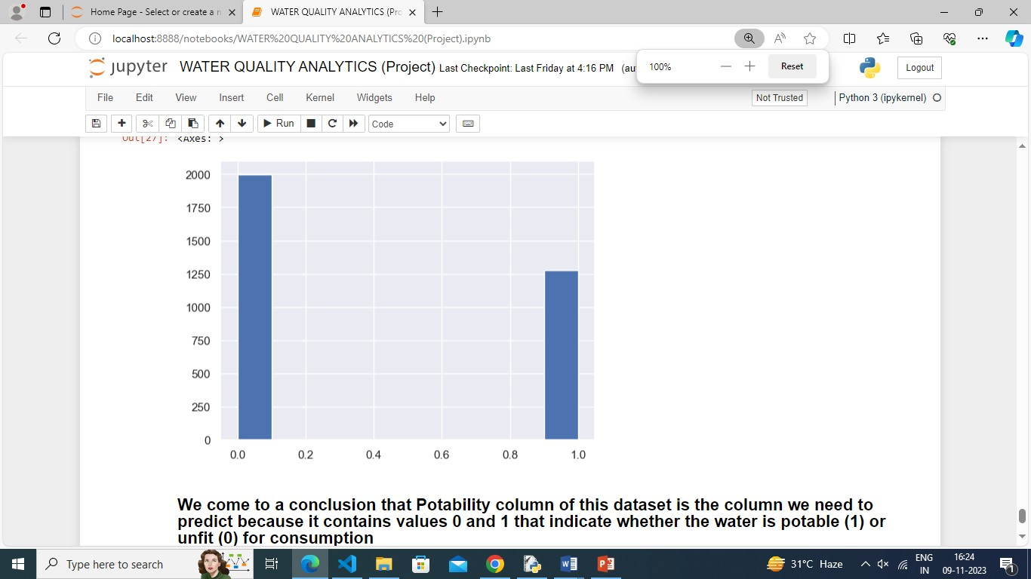 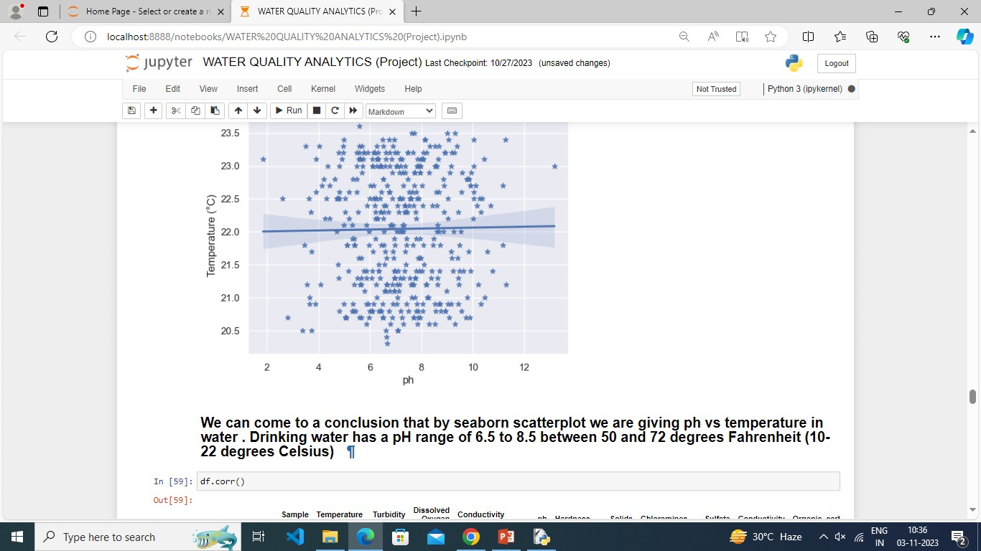 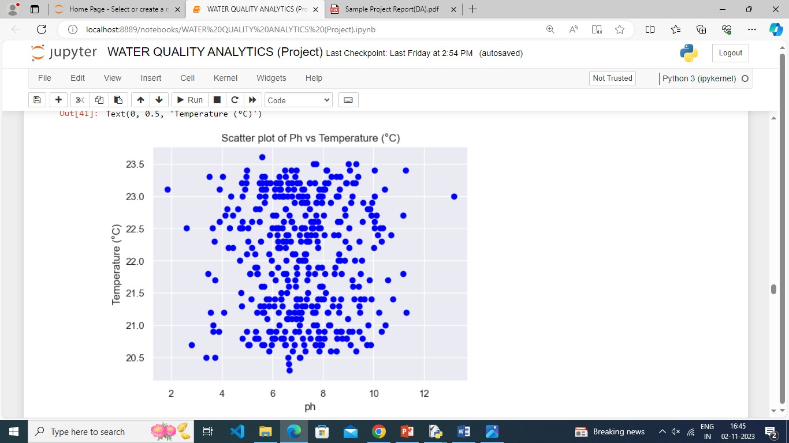







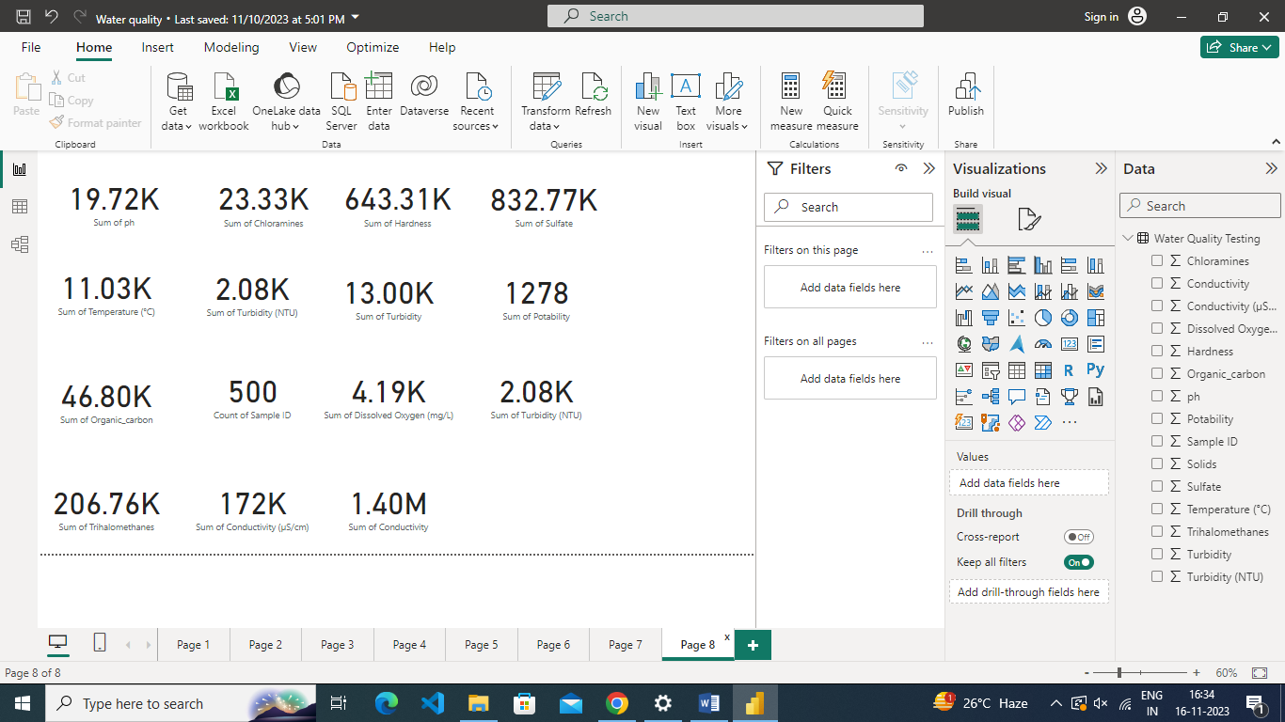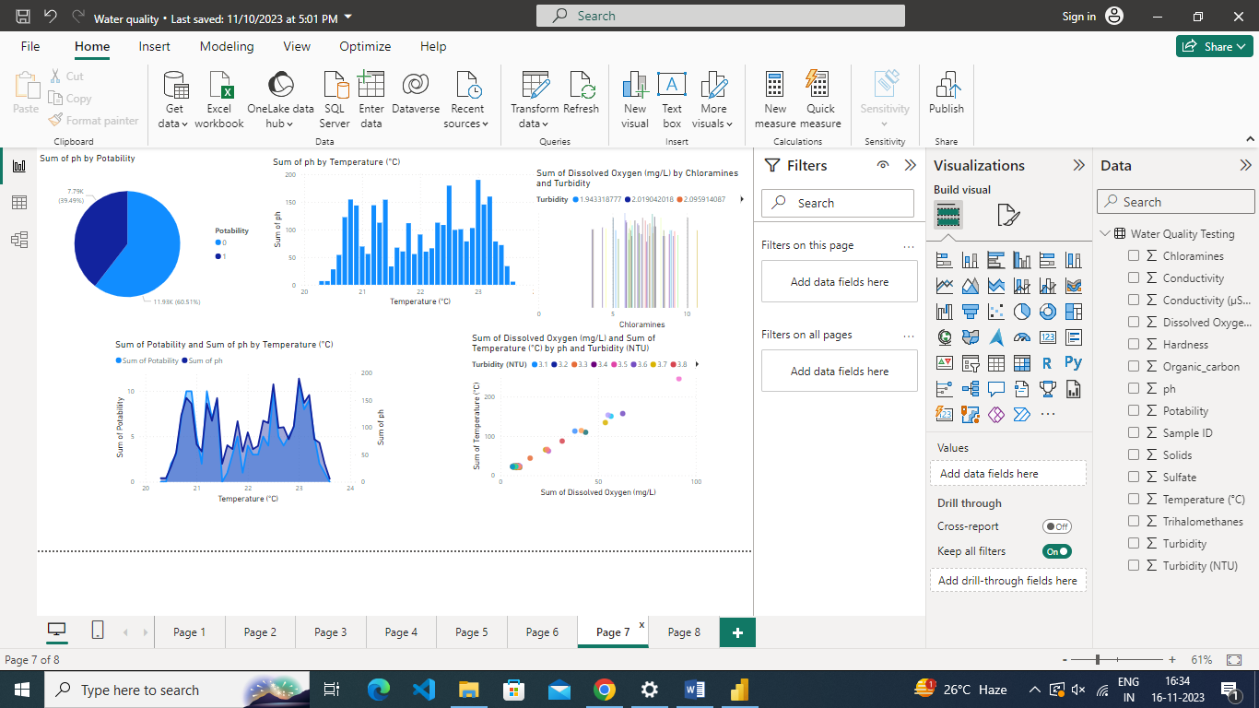

**REFERENCE**

1. <https://sensorex.com/three-main-types-of-water-quality-parameters-explained/#:~:text=The%20physical%20parameters%20include%20color,oxygen%2C%20and%20biological%20oxygen%20demand>.
2. <https://thecleverprogrammer.com/2021/08/19/water-quality-analysis/>
3. https://github.com/Manjima04/DAZZLE.git